Guide to English Literature A-level

How English Literature will be taught:
A-level English Literature is taught primarily through class discussion and debate. You will be given set texts and wider reading materials to engage with. Debate is initially led by the teacher but, as the course develops, it is an expectation that these are increasingly led by students.
Working expectations:
The amount of time you spend working out of lessons should at least match the amount of lesson time you have in a week. So, for a double lesson (1 hour 30 minutes), it is expected that you would spend at least 1 hour 30 minutes of your own time working on specific tasks set, note-taking and wider reading. To meet these expectations, you will need to manage your time effectively.
What 100% effort in this subject looks like:
- Meet all deadlines. Communicate with your teacher BEFORE the lesson if you are having trouble meeting a deadline. Do not wait for the lesson to say you haven’t done your homework.
- Before each lesson, prepare by reading and annotating your set texts. After each lesson, review and add to your notes.
- Always read with a pen in your hand.
- Refer to the mark-scheme (there is only one in English Literature) when you are writing an essay. Self-assess and make improvements BEFORE you hand in your work.
- Be proactive in making contributions to class debate. Don’t wait to be asked for your ideas.
- Re-read your set texts numerous times. By the end of Year 13, you should have read your set texts at least three times. Each time, take a different focus (e.g. focus on the development of a particular character e.g. focus on how setting changes over time).
- Commit to finding and reading a relevant article/ webpage a week. Keep a record of your findings.
Folder Policy:
Your folder should have:
- Clear, separate sections for each set text (use folder dividers). Each section will include notes, handouts and tasks in chronological order for that particular set text.
- All marked essays and mock exams should be kept in the back of your folder for reference and to show progress. These should also be in separate sections for each set text.
What Marking looks like:
- Ordinary class notes are not marked, as there is nothing to assess.
- Some homework tasks will be checked visually but not graded.
- More detailed, analytical comprehension tasks will be marked with comments.
- Essays will be marked using the mark-scheme. Feedback will be given on how the essay met the criteria. Specific targets for development will be given, and are likely to include a development task to be completed in-between essays.
What Homework looks like:
- Reading and annotating set texts/ other materials
- Answering comprehension questions
- Researching contexts
- Planning and writing essays
- Preparing presentations
Specification at a glance:
The full Specification can be found at: https://filestore.aqa.org.uk/resources/english/specifications/AQA-7711-7712-SP-2015.PDF
How are the Assessment Objectives weighted?
AO1: Articulate informed, personal and creative responses to literary texts, using associated concepts and terminology, and coherent, accurate written expression.
AO2: Analyse ways in which meanings are shaped in literary texts.
AO3: Demonstrate understanding of the significance and influence of the contexts in which literary texts are written and received.
AO4: Explore connections across literary texts.
AO5: Explore literary texts informed by different interpretations.

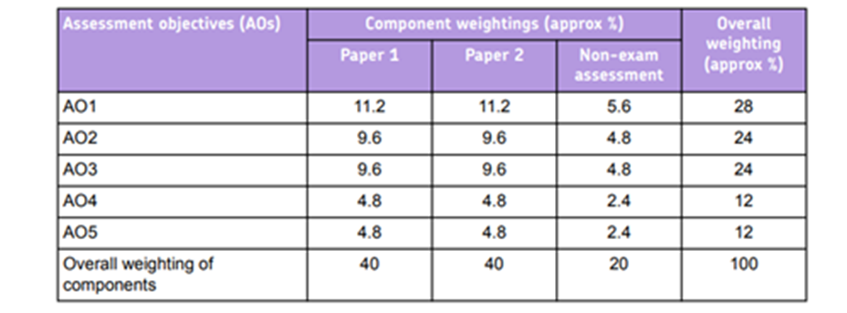

Summer preparation
- Read The Great Gatsby by F. Scott Fitzgerald.
- Watch the Baz Lurhmann film version of The Great Gatsby.
- Read a plot summary of William Shakespeare’s Othello. Re-create the plot into EITHER a 50-word summary (exactly!) OR a comic strip OR another creative form (animation/ painting/ collage…)
- Annotate the poem ‘Rapunzstiltskin’ (next page). Be ready with notes to discuss the following questions:
In what ways does Liz Lochhead write about love in surprising ways? Why do you think she does this?

To help you with this task:
- Read an online summary of the fairy-tales Rumpelstiltskin and Rapunzel.
- Think about how the maiden and The Prince are presented in the poem. How are they presented differently from the traditional fairy-tales?
- Find a definition of the term ‘Feminism’. How could you say this poem is Feminist?
- Find definitions for the terms: subversion, in media res and enjambment. Where can you see examples of these in the poem? What effect(s) do they have on the meaning/ tone/ pace?

Rapunzstiltskin
& just when our maiden had got
good & used to her isolation,
stopped daily expecting to be rescued,
had come to almost love her tower,
along comes This Prince
with absolutely
all the wrong answers.
Of course she had not been brought up to look for
originality or gingerbread
so at first she was quite undaunted
by his tendency to talk in strung-together cliché.
‘Just hang on and we’ll get you out of there’
he hollered like a fireman in some soap opera
when she confided her plight (the old
hag inside etc. & how trapped she was);
well, it was corny but
he did look sort of gorgeous
axe and all.
So there she was, humming & pulling,
all the pins out of her chignon,
throwing him all the usual lifelines
til, soon, he was shimmying in & out
every other day as though
he owned the place, bringing her
the sex manuals & skeins of silk from which she was meant, eventually,
to weave the means of her own escape.
‘All very well & good’ she prompted,
‘but when exactly?’
She gave him til
well past the bell on the timeclock.
She mouthed at him, hinted,
she was keener than a TV quizmaster
that he should get it right
‘I’ll do everything in my power’ he intoned, ‘but
the impossible (she groaned) might
take a little longer.’ He grinned.
She pulled her glasses off.
‘All the better to see you with my dear?’ he hazarded.
She screamed, cut off her hair.
‘Why, you’re beautiful?’ He guessed tentatively.
‘No, No, No!’ she
shrieked & stamped her foot so
hard it sank six cubits through the floorboards.
‘I love you?’ he came up with
as finally she tore herself in two.

By Liz Lochhead (The Grimm Sisters, 1981)

Please bring your work with you to your first lesson.

