Student Information Sheet: Remote Access and My Teams
Remote Access to Shared Areas
A link to access the shared area from home is now available on the school website:
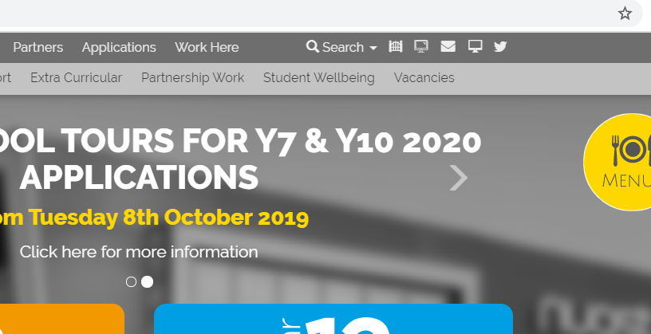

Click here to remote access the school shared area from home
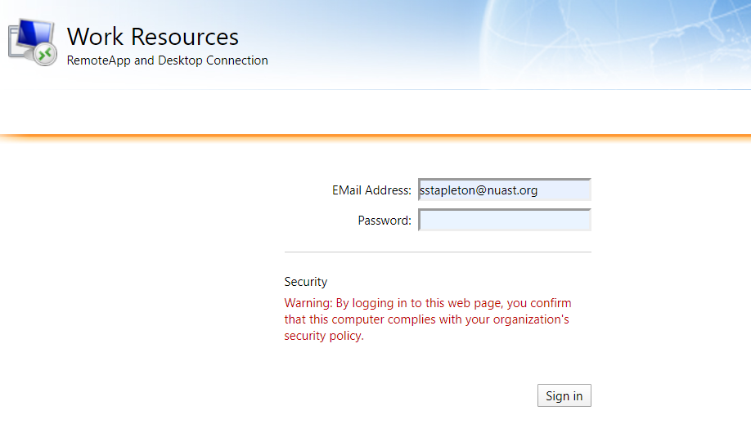
This screen will then open:
Log in using your school email address and password.

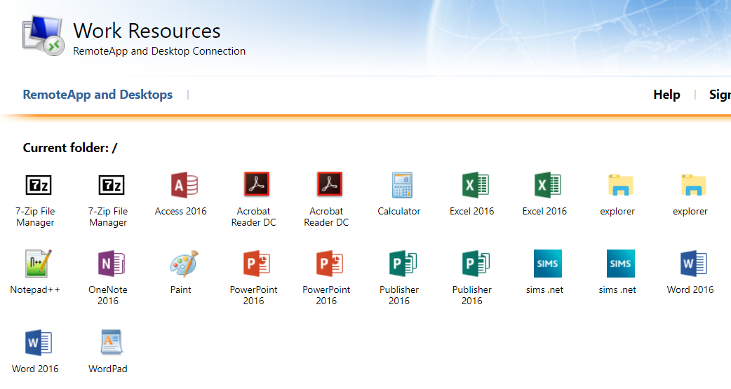
Once logged on this screen will appear:
You should be able to see Microsoft Office alongside a folder entitled ‘explorer’.

To access the school network. Click on explorer.

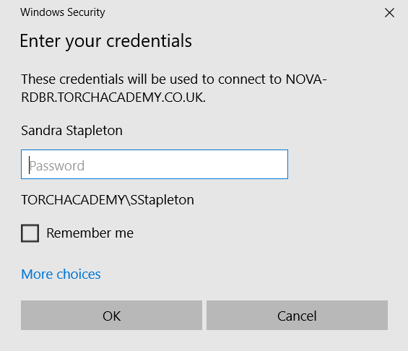
This popup will appear:

You may need to add TORCHACADEMY\ to your username if it hasn’t already been prepopulated.

Then log in with your normal password and you should be able to access the school network - both your area and the studentshared area.
Microsoft Teams
Click the envelope
To connect to Microsoft Teams follow the instructions below:
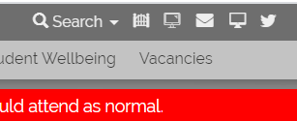
- Click on the envelope icon on the NUAST website (www.nuast.org.uk):

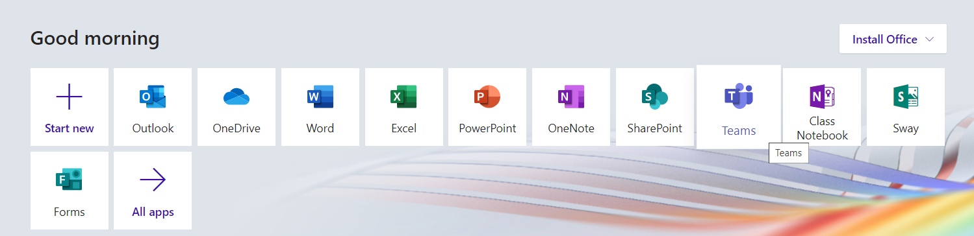
- The Microsoft Office page will open and you will be able to see all the Microsoft software available for you to use at home. To access Teams simply click on the icon that says Teams.
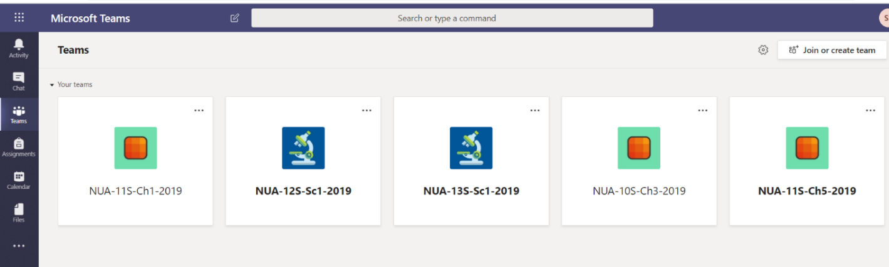
- You will then be able to see all the ‘teams’ (classes) that you have been added to. Similar to the picture below; however, you will see all of your subjects. They are named NUA (short for NUAST) followed by the year group, then the subject (i.e. Ch = Chemistry, CS = Computer Science and finally the academic year. If you have a class missing please email you class teacher to get them to add you to the group or activate the class.
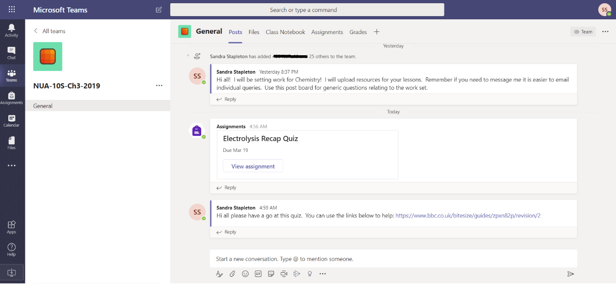
- To access a Team simply click on that class and it will take you to the page below which shows the general post board for the class:
This shows you any general posts (i.e. messages from your class teacher). It will also show any assignments that have been set.

- To complete the assignment either click on the assignment on the main post page, or alternatively click on the assignment tab and then open the assignment you want to complete. An assignment could be an online quiz or alternatively there may be a task which requires you to upload your response.
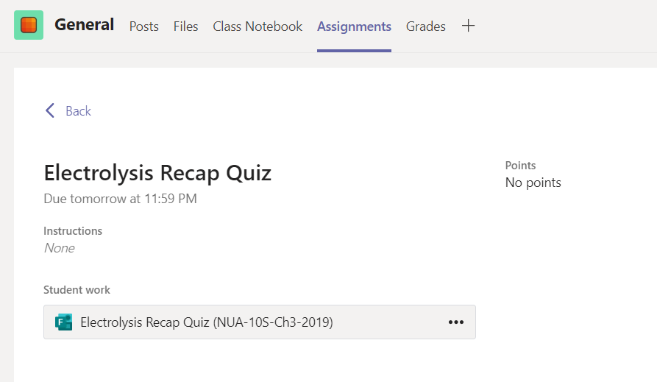
Simply click here to access the online quiz
When you have completed the online quiz simply click submit and you class teacher will be able to see and mark your submission.
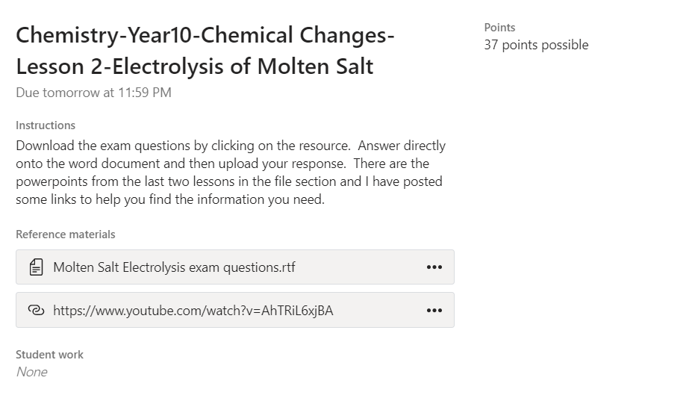
Alternatively for an assignment you may be given a written task to complete. The example to the left requires the students to complete the attached exam questions. There is a link to a video to help complete the questions.

- Once completed you upload your file/s and click ‘Turn in’. This will then allow your class teacher to see and mark your work.
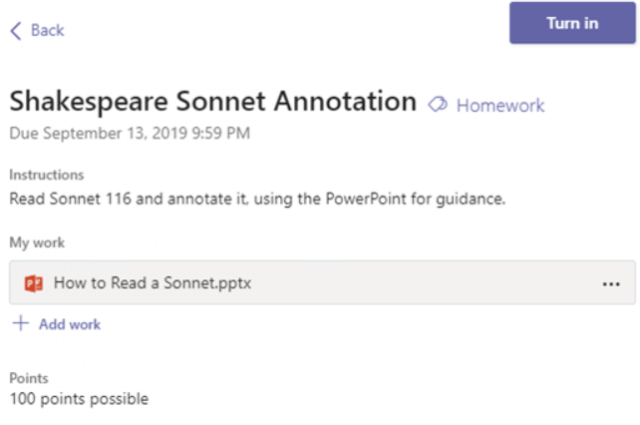

Other Tips:
Click to see your grades and teacher feedback on your work.
Navigating the Tabs
Within each team you will see the tab bar below at the top of your screen:
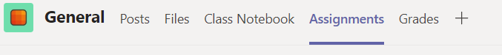

Takes you to the main post board for this class.

Click to see all of your assignments set for this team. You can see how many you have left to complete.
Click to see any additional files your class teacher has added to help you with your assignments.

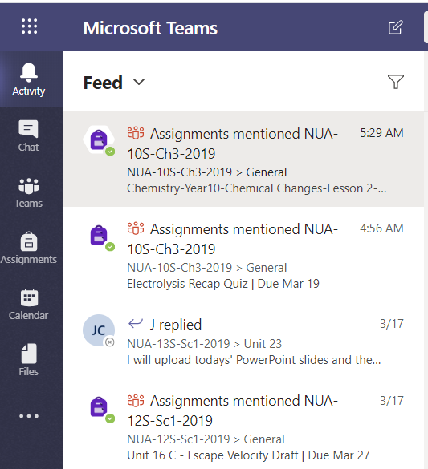
Navigating the Side Bar
This takes you to your main notifications.

Chat has been disabled by NUAST.
This takes you to all your teams/classes.

This shows you all of your assignments.
You can pull through your outlook calendar.

Another shortcut to any files added.

Extra Assistance with your Assignments
When you open an assignment or quiz in Teams you may see the button below:
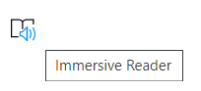
If you click on this icon it will provide additional assistance to allow you to access the text. You can:
- Get the software to read aloud the text
- Change the size of the font and line spacing
- Change the background colour
- Change the language if your first language is not English.

Support if it is not working!
In the first instance please contact your class teacher or tutor via email. All teachers email addresses are simply their first initial followed by surname and then @nuast.org.
AExample@nuast.org
If your class teacher can’t assist you, they will be able to contact additional IT support to solve the problem. All staff names can be found following the link below:
https://www.nuast.org.uk/page.php?p=staff

