A-Level Business Guide

How business is taught:
A level Business is taught via face-to-face teaching of the subject content; this is by either presentation or lecture. There is plenty of opportunity to explore business theories and models where students are encouraged to engage in discussion, debate and questioning. All students are given a supporting text book; these are to support pre and post classroom learning and homework.
Working expectations:
You are expected to put at least as many hours into A level Business outside of lessons as you would in lessons. A level Business requires a real commitment to knowledge retention due to the sheer volume of it. You will expected to use study periods to reinforce taught content, as well as develop a deeper understanding of the topics. There is also a focus on reading and writing, therefore you will need to spend time out of lessons practicing these skills as they will ultimately determine your exam success.
What 100% effort in this subject looks like:
- Attending lessons even when not you may not be feeling 100%.
- Reinforce taught content using flash cards, mind maps etc. Focus on weak areas.
- Using the supporting text to prepare for upcoming lessons, therefore being more able to contribute to classroom discussion and debate.
- Practicing essay questions from past papers and using subsequent mark schemes to understand indicative content, analysis and evaluation.
- Completing the knowledge booklets issued at the start of the course.
- Reading business news articles and keeping a record of them.
- Meeting homework deadlines.

Folder Policy:
Your folder should have:
- Course specification and content checklist at the very front.
- 6 subject dividers for Year 12 units taught across the first year and then 4 in Year 13. It is fine to have a separate folder for both years.
- After each lesson you should be filing away your notes/worksheets in chronological order. An organised folder keeps an organised mind.
- Marked essays and mock exams to be kept at the back of your folder for reference purposes and to check progress.
- Example essays and other revision materials are also to be kept at the back.
Marking looks like:
- Ordinary class notes will not be marked, although a folder check will take place periodically.
- Some homework will require self-marking and you will be given the answers on a learning platform. These will only be visibly checked.
- Some homework will be revision based, so again, only visibly checked.
- Homework that requires answering 9 mark questions and above will be marked with annotation and a grade.
- Essays questions (16-25 marks) will be marked with a cover sheet, annotation and development tasks where appropriate
- You will receive a marking coding sheet at the start of the course. This is to highlight annotations used by the teachers in essay writing and prompts for you to consider/reflect.
Homework looks like:
- Essays (generic and case study)..
- Worksheets with multiple choice and short answer questions.
- Group tasks and presentations.
- Research tasks.
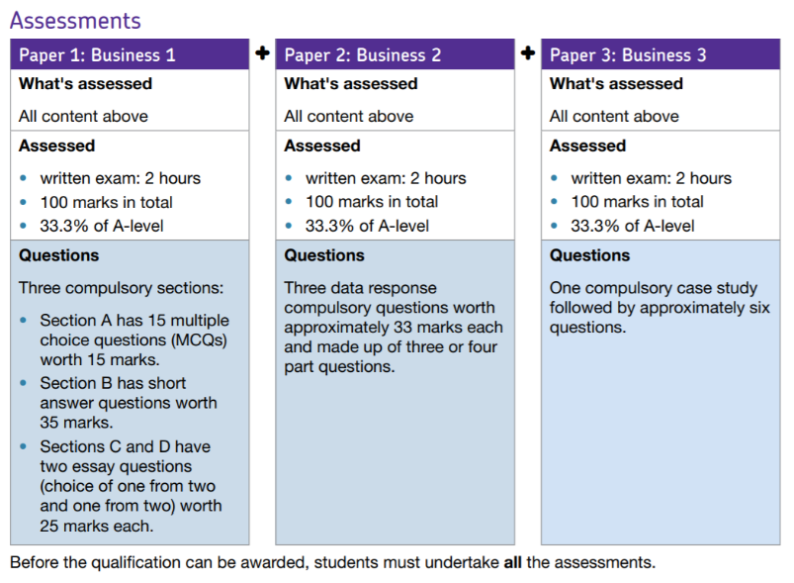
Specification at a glance:
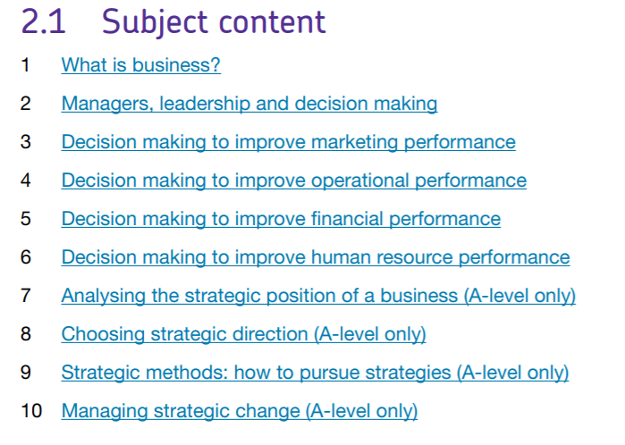

For further information about the specification, please go to https://filestore.aqa.org.uk/resources/business/specifications/AQA-7131-7132-SP-2015.PDF
Summer preparation
In order to get you ready for starting A level Business it is important that you carry out the following tasks. These will help you bridge some of the gaps between finishing your GCSE’s and starting A levels. This is particularly the case for students who did not studying it at GCSE.
Task 1: Key Terms / Definitions
In your A Level Business course you will use new terminology. These words will become part of your everyday vocabulary and the examiner will be able to credit this knowledge. To get to grips with this terminology it is worth making your own glossary. You could make flashcards to test your knowledge of the new terms. In preparation for September, research the following terms and find appropriate definitions:
- Stakeholders with some examples
- Limited liability
- Demographic factors
- Dividends
- Market capitalisation
- Economies and Diseconomies of Scale with some examples
- Rationalisation / Retrenchment
- Sales revenue
- Gross profit
- Operating profit
A useful resource for this can be found at https://www.tutor2u.net/business/topics
Task 2: New articles

Over the holidays go to either https://www.bbc.co.uk/news/business or https://www.theguardian.com/uk/business and write a summary of 10 different business related articles. This needs to summarise the issues/problems in the article, how it is affecting the business/businesses and two other stakeholder groups. In addition, if applicable, what attempts the business/businesses are doing to put it right.

Task 3: Using exam board materials
Many useful resources for your A level study are provided by the examination board – AQA https://www.aqa.org.uk/subjects/business/as-and-a-level
Spend some time exploring this website and the specification for information about the course, exam papers, mark schemes and exam reports. Practice is a key part of success at A level, so make sure you are familiar with the types of questions that can be asked.
Task 4: Watch a business related film
Here are some suggestions:
- Wall Street: Money Never Sleeps (2010)
- The Godfather (1972)
- Glengarry Glen Ross (1992)
- Boiler Room (2000)
- The Social Network (2010)
- Citizen Kane (1941)
- The Apartment (1960)
- Office Space (1999)
What was the plot and how might it relate to the business world today?

