**6th May 2020**

**Extended Project Qualification OCR (Specification H857)**

Dear Future Year 12 Student,

We are looking forward to you studying with us.

I am writing to let you know about the Extended Project Qualification which is available as an option to all Year 12 students. This letter gives you some information about it.

If, after reading this letter, you think you would like to do an EPQ project, then we would like you to begin preparing for it in the next few months before you officially become a NUAST student in September. Because a key assessment objective of the EPQ is independent learning, this extended period away from formal school as a result of the Covid-19 Lockdown is the ideal opportunity for you to get a head-start.

Read through the **Student Guide** and we suggest that a good aim for you would be to complete all the tasks in it up to and including those on Page 13 by September. It would also be a good idea for you to read through the Specification found here: <https://www.ocr.org.uk/qualifications/projects/extended-project-h857/>. Finally, to give you a taste of what previous students have done, have a look at the student exemplars here: <https://www.ocr.org.uk/qualifications/projects/extended-project-h857/assessment/>.

The type of project you choose to do is only limited by your imagination. Build a robot? Design and construct a boat? Research and write a dissertation on gravitational pull? Put on a charity event? Learn a new language? Research and present a lecture about the Cold War? The possibilities are endless!

We hope you enjoy the freedom to work on a project of your own choice. Good luck!

Yours sincerely,

Mrs S Ryce

Associate School Leader

**Extended Project Qualification OCR (Specification H857)**

**Course Summary**

|  |
| --- |
| **This AS Level is highly valuable:**   * Future employers will see that you can work independently and use skills like planning and managing a long-term project effectively. * Universities will see that you have the skills to manage your own learning effectively. * You can deepen your understanding in an area that really interests you. * It can give the competitive edge with university and employer applications. |

**WHAT IS THE OCR EXTENDED PROJECT?**



* The equivalent of half an A Level, but with an A* also achievable.
* Aims to develop you beyond your existing study programme by giving you the freedom to complete a project on an area of personal interest or benefit, while developing project management skills along the way.

**WHAT DO YOU HAVE TO DO?**

Choose, plan and manage a project. An outcome could be:

* a dissertation/investigation/report
* an artefact or design
* an event
* a performance of some kind

Alongside these outcomes, you need to keep **a documented record of the project management process**.

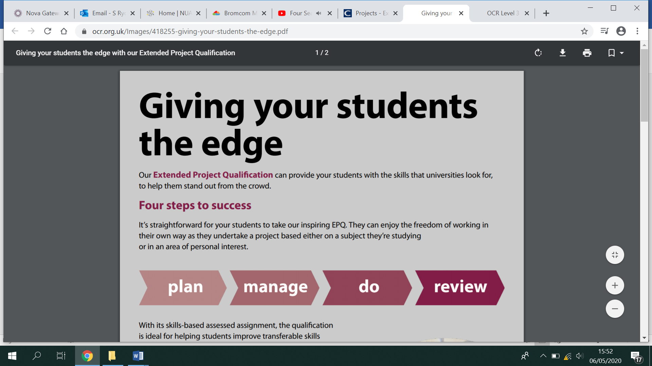

**HOW IS THE EPQ ASSESSED?**

You are assessed on your ability to manage your project:

**AO1 Manage**: Identify, design, plan and carry out a project, applying a range of skills, strategies and methods to achieve objectives. (12 marks max)

**AO2 Use resources**: Research, critically select, organise and use information, and select and use a range of resources. Analyse data, apply relevantly and demonstrate understanding of any links, connections and complexities within the topic. (12 marks max)

**AO3 Develop and realise**: Select and use a range of skills, including, where appropriate, new technologies and problem solving, to take decisions critically and achieve planned outcomes. (24 marks max)

**AO4 Review**: Evaluate all aspects of the Extended Project, including outcomes in relation to stated objectives and own learning and performance. Select and use a range of communication skills and media to present evidenced project outcomes and conclusions in an appropriate format. (12 marks max)

You are given a total mark out of 60, based on the evidence you provide to show that you have met the above criteria. It will then be sent to OCR for external moderation.

You can gain a maximum of 28 UCAS points.

**WHAT GUIDANCE CAN YOU EXPECT?**

You will complete the project in an academic year. To guide you, you will receive a mixture of taught sessions and one-to-one supervision. You are expected to spend 90 hours working independently.