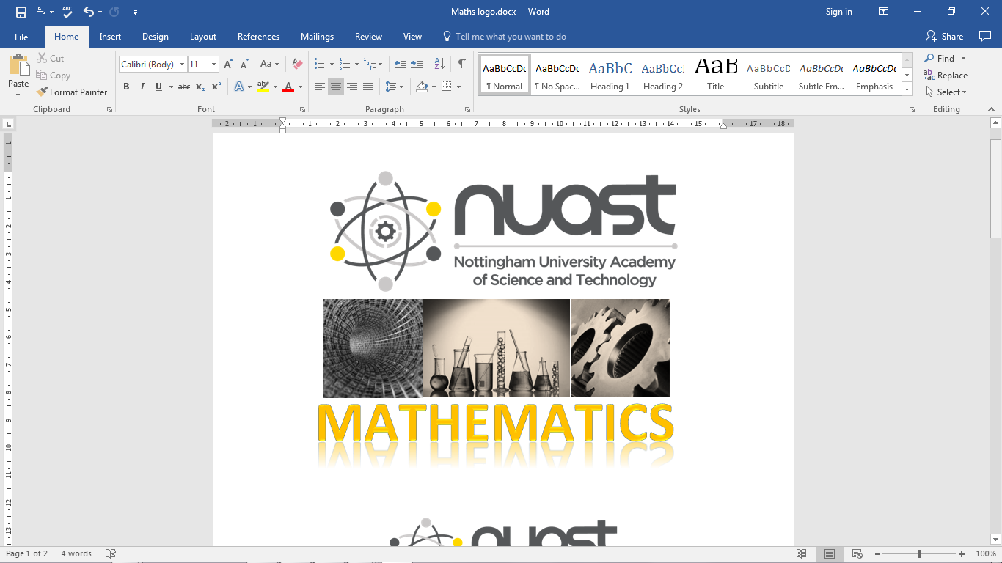

**Mathematics**

|  |  |
| --- | --- |
| What A2 content has already been covered in Year 12? | A2 Pure Maths Chapter 1 – Algebraic fractions, partial fractions & proof by contradiction  A2 Pure Maths Chapter 4 – Binomial expansion  A2 Pure Maths Chapter 5 – Radians: arcs & sectors; trig equations; small angle approximation  If you missed any of the topic tests for the Y2 Pure Chapters 1, 4 & 5 you will need to complete these using your study periods in the first week back in September |
| Summer Maths study checklist | * Finish **corrections for all mock papers** & review against model solutions * Update, review and organise your **assessment folder**, including updating the summary checklist. Note this summary sheet should have a record of your practice papers and exams too. * Check you have finished all of the Y2 Pure Chapter 1, Chapter 4 and Chapter 5 textbook exercises & the review homeworks. Follow up with the recommended **development tasks** for these chapters as appropriate. * Consider if you need to revisit any of the Y1 topic chapters for more practice. * Do one more practice AS paper 1 and 2 as a final check on your year 1 coverage. * Watch and enjoy the 20 minute TLMaths video[*CURRENT SPEC A-Level* ***Maths Graphs YOU MUST KNOW HOW TO SKETCH!***](https://www.youtube.com/watch?v=vd714NIXZd4) (see teams/e-mail for a direct video link) * Complete the Large data set ***Investigation 3 – Sampling methods*** from Student resources (you also need the ***Dates*** spreadsheet in this folder) * Watch and enjoy the 15 minute Exam Solutions video:[***Connected particles****: Greatest height reached by a particle when the other hits the ground*](https://www.youtube.com/watch?v=uP7RBWsoQ44)(see teams/e-mail for a direct video link) |
| What additional independent study can I complete in order to further stretch my subject knowledge and curiosity? | Use Desmos or Geogebra to ***investigate the Modulus function*** – this file is in Student share, Y2 Core Chapter 2 Functions, problem solving folder (this topic is studied in Sept. year 13)  See some further interesting mathematical problems to explore at the links below:  <https://undergroundmathematics.org/thinking-about-functions/thats-odd-or-even>  <https://undergroundmathematics.org/polynomials/general-tragedy>  <https://undergroundmathematics.org/calculus-meets-functions/curvy-cubics>  **Unifrog**: *Subjects library / read the profile* offers valuable wider reading recommendations for your chosen degree subject. |
| How will Year 13 in **Maths** be different to Year 12? | The routines of successful mathematical study at A level should now be established and most new learning builds on year 12 work. The level of challenge in calculus and trigonometry builds significantly, often drawing on multiple techniques within any given problem. The challenging topic in statistics is the normal distribution. In mechanics the big step up is working with moments, projectiles and with inclined planes – we learn to deal with motion and forces in component form.  We are making significant changes to the groups for September, to give us classes of around 20 students. Ms Barr, Miss Garton, Mr Bradd-Kerr, Mr Ledger, Mrs Morgan & Dr Stoker will all be teaching Y13 Maths.  There will be some targeted period 6 maths intervention sessions running for year 13 students. This information will be shared with parents as well as students. |
| How will my UCAS predicted grades be decided for Maths | Your end of year 12 exams provided us with good evidence for the predicted grade reported in July but we also look at other evidence before selecting your predicted grades for UCAS:   * Your mean topic test scores from Y12 Maths * Your mean topic test scores from Y13 Maths topics completed * Your attitude to learning grades, reported in July   We take account of the increasing demand of year 13 content and so we will focus particularly on the newer evidence provided from assessments of more recent coverage. We are keen to support your high aspirations for finding the best university for you but we also need to help you secure an offer that you can achieve. |
| What do I need to do that I wasn’t doing in Year 12? | From early on in year 13 you need to start completing **past exam papers** out of lesson time. The most demanding element of exam success is building confidence in selecting the mathematics to use, solving any particular problem. Initially students need to progress through working on past exam papers that are pitched at AS content. As with all maths, it is important to focus as much on the marking phase as solving the problems. Fully detailed exam solutions can be easily accessed online but you must learn to avoid turning to a ready-made solution before exhausting strategies that you can use to move towards solving a problem yourself – understanding someone else’s solution has far less impact on your learning than solving it for yourself.  We make a particular point of building your experience with ***Modelling and Problem solving*** as students may find that even with confident mastery of the mathematical techniques being learned, the context included in a question can lead to underperformance in exams.  Take up the opportunities for **support** on offer: check your frees against your teachers’, plan to attend intervention sessions, use the quiet study spaces in the villa to make best use of your study periods.  Take every opportunity to talk maths with your fellow students and teachers – explaining a mathematical idea is one of the best ways of learning it! Never leave a problem unresolved. The hard work starts straight away.  **Good luck!** |

WITH GREAT FOUNDATIONS YOU CAN LOOK FORWARD TO A SUCCESSFUL YEAR 13

